Date: __________________________
OEC Physician: _________________________ Family Physician: ________________________
Patient Name: _________________________ Age: ______ Weight: ________ Height: ________
Marital Status: __________ Children (how many?): _____ Occupation: _________________
Email Address:______________________________________________________________________
Name of Person Driving you Home: Phone: __

MEDICAL PROBLEMS: How long? All Surgeries/Hospitalizations When?
⧠ High Blood Pressure _________ _________________ _________
⧠ Heart Disease / Angina _________ _________________ _________
⧠ Heart valve replacement _________ _________________ _________
⧠ Diabetes _________ _________________ _________
⧠ Liver disease _________ _________________ _________
Other problems: _________ _________________ _________
___________________ _________ _________________ _________
___________________ _________
___________________ _________

MEDICATIONS: ⧠ Aspirin ⧠ Anticoagulant (blood thinner) __________________________
All other medications: ____________________________ _______________________________ ____________________________ _______________________________ ____________________________ _______________________________

ALLERGIES (Drugs):_______________________________________________________________

Latex allergy? Circle Y or N

Alcohol use? Circle Y or N Average # of drinks per DAY? _____

Do you smoke cigarettes? Circle Y or N How many per DAY? _____

FAMILY HISTORY OF: Relative (which side - Mother’s or Father’s?)

Colon cancer / polyps ___________________________ Age: _____

Endometrial / Ovarian / Breast cancer ______________________________ Age: ______

Liver Disease (Cirrhosis, Hepatitis) ______________________________ Age: ______

Inflammatory Bowel Disease ______________________________ Age: ______
(Crohn’s Disease, Ulcerative Colitis)
Please turn over →
SYMPTOMS:

Number of bowel movements per day:____________

Has there been a change in bowel habit? Yes / No. For how long? _________________________

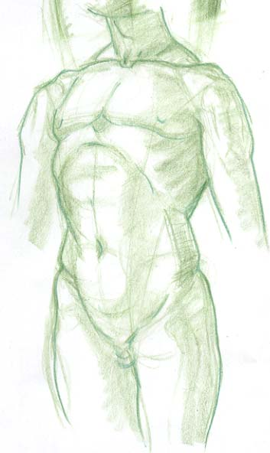 Stool Consistency:
⧠ Normal Consistency
⧠ Semi-formed Consistency
⧠ Watery Consistency
⧠ Hard Consistency

Rectal Bleeding: Colour:
⧠ None ⧠ N/A
⧠ Toilet Paper ⧠ Bright Red
⧠ Coated on Stool ⧠ Maroon
⧠ In Toilet Bowl ⧠ Black

Abdominal Pain: Circle Yes or No Where? (mark with X)

Weight loss: Circle Yes or No How much? ________

Any other symptoms: Circle Heartburn / Problems Swallowing Food or liquid / Nausea or Vomiting
Other:_________________________________________________________________________________

Previous colonoscopy? Circle Yes or No When? ____________ (month/year)
Previous barium enema? Circle Yes or No When? ____________ (month/year)
Previous stool blood test? Circle Yes or No When? ____________ (month/year)

Previous CT (Cat Scan) Colonography? Circle Yes or No When? ____________ (month/year)
(a special CT screening for bowel cancer)

________________________________ __________________
Patient Signature Date
_____________________________________________________________________________________
DOCTOR TO FILL IN –

Anesthesiologist, Dr. __________________________________________________

PHYSICAL EXAM:

Malampatti Class: 1 ____ 2 ____ 3 ____ 4 ____

COLONOSCOPY / GASTROSCOPY:

Midazolam _________ mg

Fentanyl _________ mcg

- Diverticulosis

ASA Class: P1 ____ P2 ____ P3 ____ P4 ____ P5 ____ P6 ____

Prep quality: (R) ____ (M) ____ (RS) ____ Fluid ____ Total ____
(0-4) (0-4) (0-4) (0-2) (0-14)

Presumptive follow-up interval:
- colonoscopy in _______ years
- gastroscopy in _______ years

